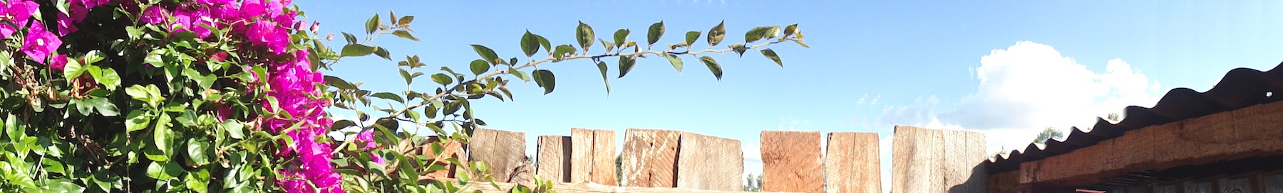
To whom it may concern,
I would like to start off here with a simple and exuberant Thank you. Thank you for helping this fantastic experience become reality. This trip was far from cheap but through the financial help you participated it was reasonable and well worth the experiences I gathered.
I would normally try to make my traveling plans for a slightly longer period than the twelve days we were able to spend on this holiday. But seeing that we were pressed for time and that we packed in as many days and as many adventures that we could between the semester end (we left Friday morning of finals week) and Christmas, (I traveled a bit longer to get back to Michigan for family and didn’t arrive till the twenty third) I see that it was well planned. So a bit about what I learned on this Agricultural study to Kenya
Professors David Wilson and Urszula Norton, along with doctorate students Emmanuel Omondi and Nate Storey did an excellent job – of not only splitting up learning opportunities and the sharing of their own individual techniques and knowledge sets – but for instigating and executing the trip, participating in the education of students on an individual basis, and learning as much possible for themselves along the way.
We had been briefed extensively before we left and yet still, all the research, and mental preparation could prepare you for someplace you’ve never been, only dreamed of having explored. We came along to this side of our little blue planet to learn, to be taught, learned upon, and perhaps even learnt from. Such is the ‘nature of things’ that one hopes for, is it not? Our dear friend Emmanuel has been gracious host and simply a man of many things, I felt honored to be glimpsing this view his life. Our stay at the Manor House (where he is head director) and the surrounding farms and cultural centers in which they have had a noticeable impact was a very educational experience.
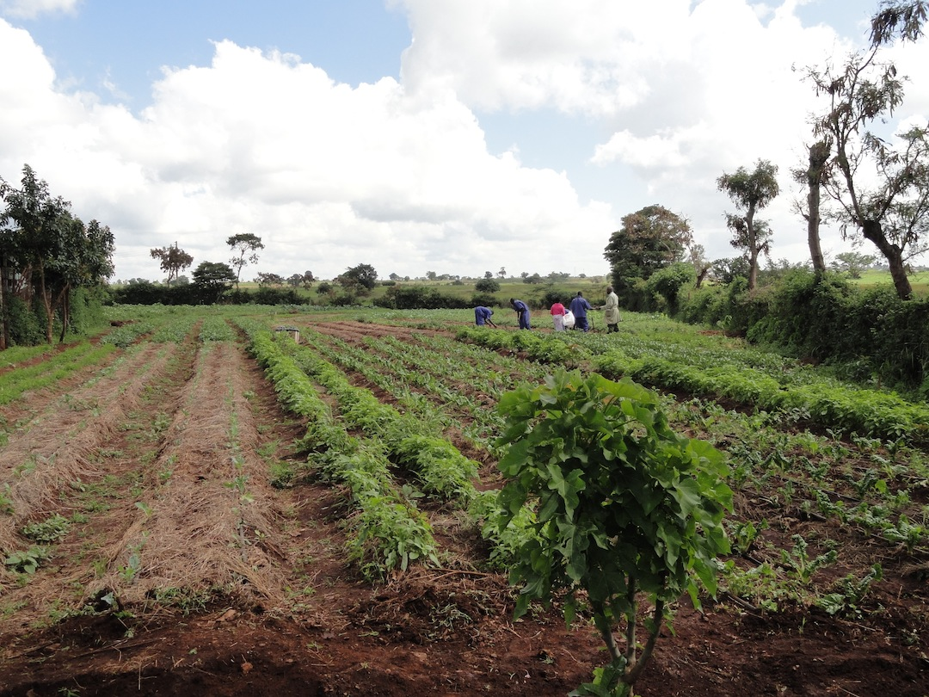
As a group of students that weren’t necessarily all students of agriculture we were well informed on all the basics of what we were studying, why, and how it has been changing in these regions for the last handful of years. How that with the British rule and the practices of growing in large monocultures led to this being the known way of farming in the region. That with the implementation of bio-intensive agriculture (B.I.A.) has led to increased crop production, water retention, and over-all soil fertility. Through the practices crop rotation, no-till or low-till tillage, double digging, organic animal dung and farm waste compost, and careful watershed management they have reclaimed much of the knowledge that was once common practice. These are the types of ideas that the Manor House trains teachers and community leaders to spread.
We explored the large-scale cut flower farms of the Lake Navasha region, the large corporate tea plantations, all the way down to local community outreach centers and family-sized substance farming. We learned about the importance and large roles that Nongovernmental organizations (N.G.O.’s) can play in a country without many of the means to carry out what is often taken for granted in countries such as our own. We explored the importance of animal husbandry; not only in regards to protein acquirement, but the role they play in organic nutrient recycling in these limited closed-loop systems.
We traveled to three National Parks. (Nairobi, Hell’s Gate, and Maasi Mara) Went on nature walks and adventure hikes. Hell’s Gate was extremely enjoyable for myself. A deep gouge in the arid landscape proving that on occasion this area could be a tumultuous scar of impassable ravines and raging rivers; sandstone slot canyons and monolithic pillars hundreds of feet tall; Acacia trees that could nearly run one through if you were to accidentally walk into one; and raucous baboons running the show. Along with some of the best-looking rock climbing I have ever seen, only, if we had tried to approach the rock for a try, we’d truly be asking to be lunch for one of these great beasts! We spent time on Safari in Maasi Mara N.P. and were able to experience all of the quintessential vistas one pictures when Africa is mentioned. The spreading savannah with a healthy scattering of buffalo herds, gazelles, giraffe, lions, elephants, rhinoceroses, birds of all types, and all the beautiful creatures of this great land.
This was truly an experience of a lifetime. I say that because I probably wouldn’t have made it to Kenya without this sort of opportunity through the College of Agriculture and certainly not on such a remarkably in-depth level. Though, on this note, I have heard of the possibility of having students able to go to Kenya for an extended stay and more intensive study at the Manor House, itself. This would be an excellent opportunity for any students able to be involved in such a venture. Indeed, there was an interview processes while we were at the Manor House in-order to find suitable candidates for an exchange program. Making this a life changing opportunity for all included and I sincerely hope that this shall be a possibility for worthy students in the near future.
Once again, thank you for the help in making this exciting, educational trip a possibility.
Warm regards,
Liam Stockwell
